**For each of the questions below, answer with an ArrayList declaration with the most specific type, if any, that can work. For instance, the ArrayList that could contain Cat objects is ArrayList<Cat>**

**1. contain Pomeranian objects**

ArrayList<Dog>

**2. contain Pomeranian and Cat objects**

ArrayList<Pet>

**3. contain objects of any of the above types that you can call the eat() method on.**

ArrayList<Pet>

**4. contain GreatDane objects that you will only call the sleep() method on**

ArrayList<Pet>

**5. contain Pomeranian and Siamese objects**

ArrayList<Pet>

**6. contain Pomeranian and Siamese objects that you will call yap() and ignoreYou(), as appropriate**

ArrayList<Pet>

10.5.1

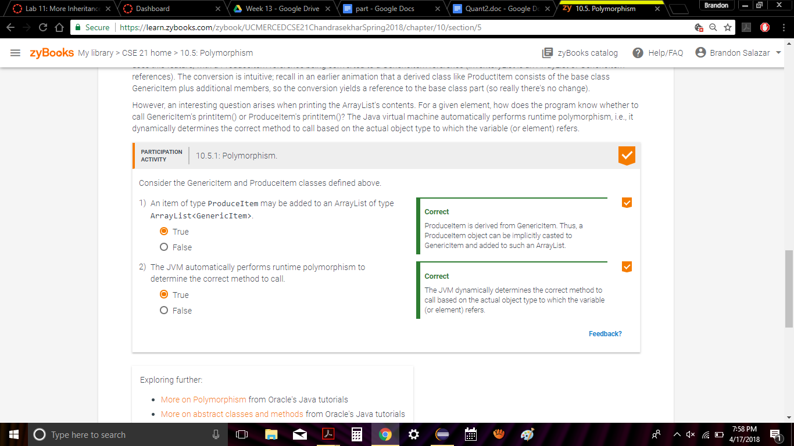

10.6.1

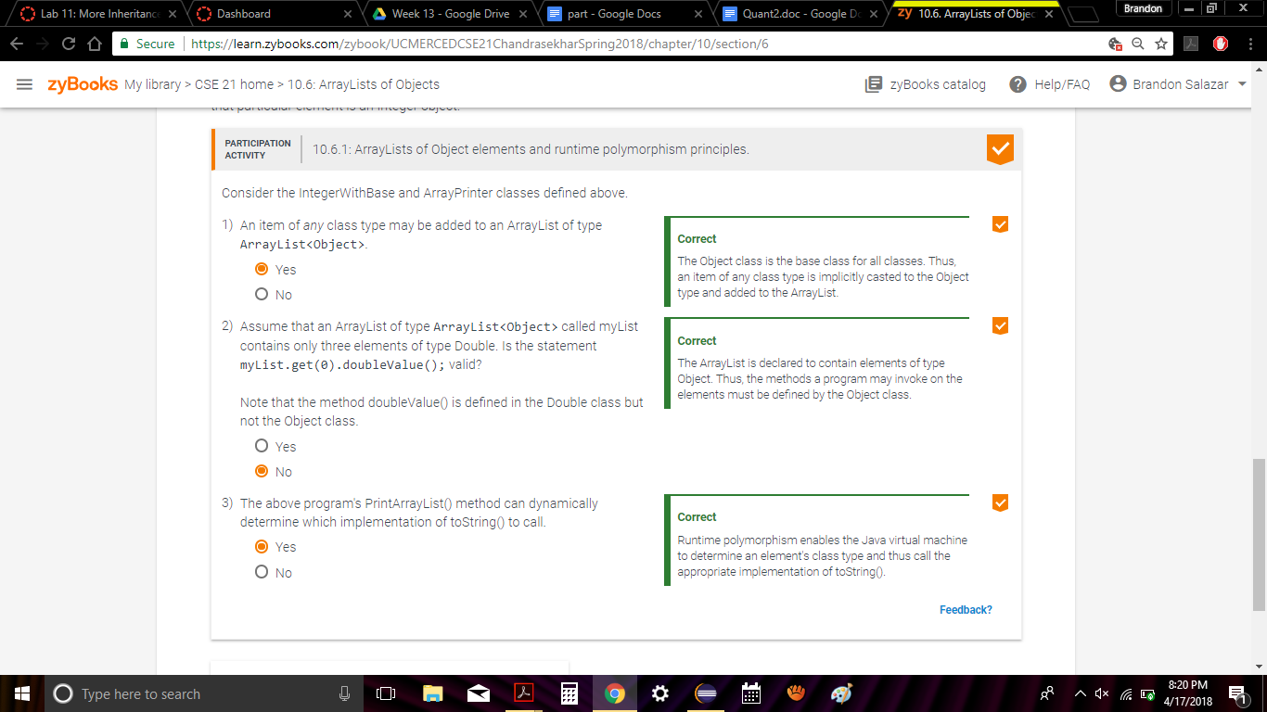

10.7.1

